Using External iLogic Rules

Introduction
When defining/creating iLogic based rules in Autodesk Inventor, these rules are created and stored within a specific document. Many times these rules will need to be applied to multiple documents. Opening each document and creating the same rule is time consuming and labor intensive in both the creation and maintenance stage. This document will outline the process for using externally defined iLogic rules in Autodesk Inventor documents.

Defining the External Rule Location
In order to effectively use external rules you must first define the location where these will be stored.

- On the “Tools” tab in Autodesk Inventor, click the down arrow at the bottom of the “Options” panel and select “iLogic Configuration”.

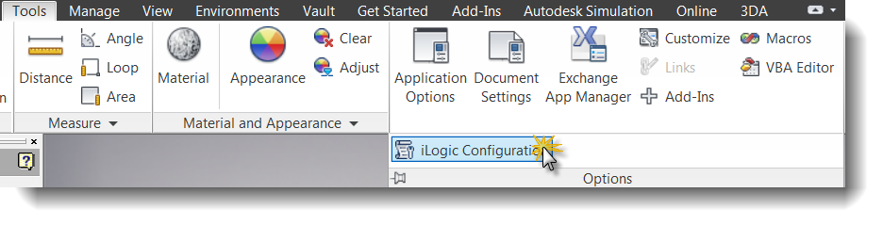
- Click the “+” button and select the directory where you will be storing your externally defined rules.

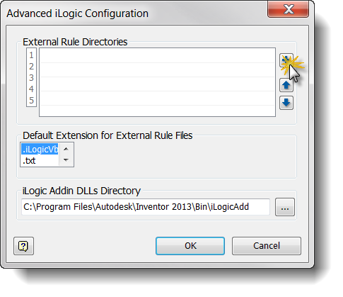
- Click the “OK” button once you have defined the location.

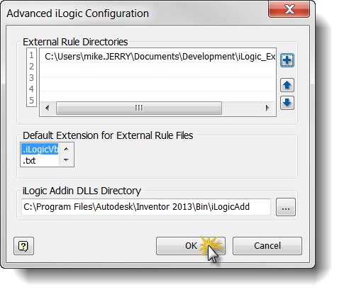

Creating External Rules
Once you have defined the location to store the rules, you then can go about creating the rules. This is done in the standard iLogic “Add Rule” functionality.

- From the “Manage” tab, click the “iLogic Browser” button in the “iLogic” panel.

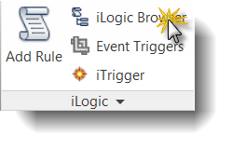
- Click the “External Rules” tab in the iLogic browser.
- Right-click on the “External Rules in Files” and select “Create New External Rule”.

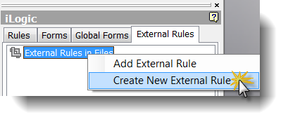
- In the “Create Rule File” dialog box, navigate to the directory you defined in the previous section and give the rule a name. For this example, we will be creating 2 rules. The first to create PDF files, the second to create a JPG file. These rules will be named “PDF_Export” and “JPG_Export”.

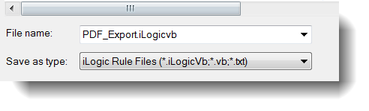
If your specified directory is outside the defined project path, a dialog specifying this will display. Click “Yes” to close this message.

- Enter the code for your rule in the “Edit Rule” dialog box. For this example we are using a very simple rule:

pdfName = ThisDoc.PathAndFileName(False) & ".PDF"
ThisDoc.Document.SaveAs(pdfName , True)

- Click OK to close the rule editor.

Repeat steps 1-6 above substituting “JPG” in place of “PDF” to create the second rule.

Using iLogic Forms to Call External Rules
This next step is not required but it is a good opportunity to speak about the use of iLogic Forms as well. Forms, like Rules, can be defined within a document or externally. These are called “Global Forms”.

- In the iLogic browser, click on the “Global Forms” tab.
- Right-click in the panel and select “Add Form”.

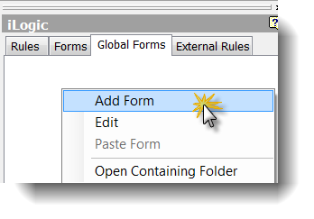
- In the “Form Editor” dialog, give your form a name. In this example, our form will be called “Export Tools”.

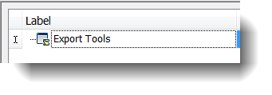
- Click the “Rules” tab then click and drag the defined rules to the forms window.

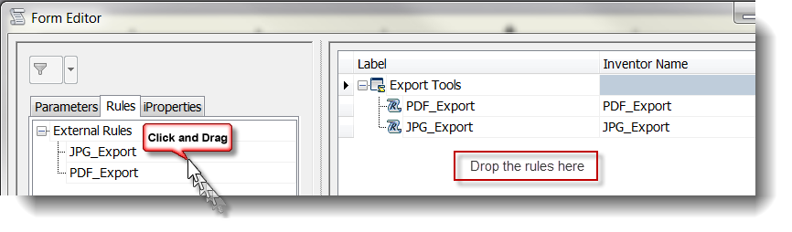
A preview of the form will be displayed while you are editing it.

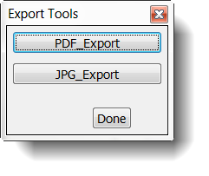
- You can be as creative as you want within the form, customizing it to look however you want it to. For this example, we will leave it with just the two buttons.
- Click “OK” to close the form editor.
- This form can now be called by clicking on the button in the “Global Forms” tab of the iLogic browser.

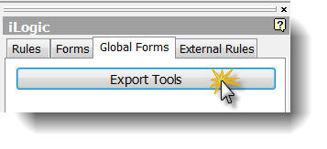

Your form will be visible during your current Inventor session until you close it. The next time you launch Inventor, you can simply click on button as you did in step 7 above and your form is back.

